TITLE : MALNUTRITION

Group Members :
 | MATRIC NUMBER | NAME
1. | 67231 | NUR SYAFISA BALQIS BT ISKANDAR
2. | 65762 | DAYANG AMIRAH NABIHAH BT AWANG TAMBUN
3. | 67399 | NURUL SHAZWANIE BT HASSAN
4. | 66764 | MUHAMAD FADIL BIN ABDUL JALIL
5. | 66720 | MOHD NOR HIKMAN BIN SAUFI

Terminologies
Terminologies | Definition | Categories (Englisha/Medical)
Cassava | Is a root vegetable which is widely consumed in developing country. It provide some important nutrient and resistant starch, which may have health benefits. But can have dangerous effects if it is eaten raw and in large amounts. It’s a woody shrub native to South America of the spurge family

Facts | Ideas | Learning outcomes | Action plans | References
The daughter’s abdomen started to swell and her arms and legs very thin and rib poking through her chest. Her hair started to go yellow reddish colour and start fall out | - Why her abdomen started to swell and her arms and legs very thin and rib poking through her chest? |  | - Her abdomen started to swell due to protein deficiency. Kwashiorkor is a serious condition that happen when a person does not consume enough protein. Severe protein deficiency can lead to fluid retention which can make the stomach look bloated. This disease is common in children especially if they do not have access of adequate nutrition soon after they stop breastfeeding. Immediate medical treatment or attention must child undergo if they experience kwashiorkor. (Why does malnutrition cause stomach bloating? Medical News Today March 15 2020). Swelling of the abdomen is because of lack of strength of muscle of abdomen, which causes the content of the abdomen to bulge out making the abdomen swollen.  - The legs and arms become very thin due to the muscle wasting and lack of strength in the muscle. Limbs may appear stick like. Rib poking through her chest is may be because or obvious weight loss with muscle wasting. There is little or no fat beneath the skin. The skin folds are thin and the face appears pinched like an old man or monkey. | - https://www.medicalnewstoday.com/articles/322453  - https://www.news-medical.net/health/Symptoms-of-malnutrition.aspx
 | - Why her hair started to go yellow reddish colour and fall? |  | - Her hair started to go yellow reddish colour and fall because of Kwashiorkor which is the lack of protein for hair growth.
She kept try feed her, she wasn’t interested and turn her head away | - Why she didn’t want to eat? |  | - She didn’t want to eat because malnutrition or Kwarshiorkor patient commonly lose thier appetite and may not feel hungry even though thier body need food. This is because the muscle of stomach started to shrink from time to time. Therefore, she didn’t have appetite to eat. | - https://www.ncoa.org/healthy-aging/chronic-disease/nutrition-chronic-conditions/why-malnutrition-matters/5-malnutrition-facts-older-adults/
Son (kakabo) grade started to drop and received report from his teacher that he was falling asleep in class. He always tired and become thin and fat at the same time | - Why malnutrition patient become thin and fat at the same time? |  | - This can be due to having a diet consisting of food and drink that’s high in fat and sugar but low in essential vitamins and minerals. However, person with undernutrition can also be overweight if they eat a diet high in energy (calories), but low in other nutrients and vice versa. | - https://www.nhsinform.scot/illnesses-and-conditions/nutritional/malnutrition
 | - Why he falling asleep in the class? |  | - Because he didn’t get enought vitamins, mineral and protein. Therefore, he can not focused in the class.
We should go to the health center because this could cause by the food we are feeding our children. We feed our family sweet potatoes, bananas, and cassava | - What caused the malnutrition? |  | - Sweets potatoes, bananas and cassava does not provide much contain of protein, vitamins, and minerals that they need which can cause malnutrition.
Kenyangey was need medical treatment and if she didn’t get it she could become even more sick, even more die. | - Why do malnutrition patient should get treatment? |  | - Malnutrition patient should undergo treatment because acute malnutrition weakens the immune system, which then becomes more susceptible to developing diseases that can be fatal. Moreover, they should get immediate treatment because some can cause a significant increase in illness and even death from this disease
 | - What type of treatment that malnutrition patient should undergo? |  | - The type of treatment that malnutrition patient should undergo depending on what’s caused a person to become malnourished and how severe it is. The type of treatment is such as feeding tube to provide nutrient directly into the digestive system and a drip to provide nutrient and fluids directly into a vein. Next, tools that are used to identify malnutrition include weight loss, body mass index (BMI) chart, blood tests for micronutrient status and physical exams. | - https://www.nhsinform.scot/illnesses-and-conditions/nutritional/malnutrition  - https://www.healthline.com/nutrition/malnutrition#symptoms
If child as malnurage, stomach doesn’t work properly anymore and giving them normal food could give them very ill. She would get special food from the hospital. | - What cause the stomach doesn’t work properly? |  | - Malnutrition leads to inflamed intestines. The lack of protein in the diet or low levels of amino acids, the building blocks of proteins, can lead to symptoms like diarrhoea, inflamed intestines and other immune system disorders, which weaken the body and can be fatal. | - https://www.sciencedaily.com/releases/2012/07/120725132133.htm
 | - Why do malnutrition patient can’t give normal food which could give them ill? |  | - Malnutrition patient can’t give normal food which could give them ill is because the food can not be digest properly. Malnutrition causes digestive problems and issues with nutrient absorption. This condition that cause malabsorption, such as Crohn’s disease, celiac disease and bacteria overgrowth in the intestines, can cause malnutrition.
 | - What type of food did the hospital give her? |  | - Type of food did the hospital give her are fluid-like food. This is because she was diagnosed with severe acute malnutrition, which means she posses most of the symptom such as have no appetite. Therefore, hospital will give her a drip to provide nutrient and fluids directly into a vein.
Malnutrition is cause when you don’t eat enough food or you don’t eat the right variety of food | - What is malnutrition? |  | - Malnutrition is a condition that results from nutrient deficiency or overconsumption. | - https://www.healthline.com/nutrition/malnutrition#prevention-and-treatment
 | - What is the right variety of food that we should consume? |  | - The right variety of food that we should consume to prevent malnutrition is by including and providing minerals such as iron, zinc, and iodine pills. Food supplement can also one of the most effective way to prevent these disease. In addition, physical activity and healthy food choices for children and adults at risk of overnutrition may help prevent overweight and obesity.
Malnutrition is not all about quantity but also quality of food taken. | - Why malnutrition is not all about quantity but also quality of food? | - To learn about the relationship between the quality of food and malnutrition | - WHO Director, Department of Nutrition for Health and Development, Dr Francesco Branca said “The concept of food security to the concept of nutrition security. It’s not just the quantity of food we are providing, but also the quality and we need to consider from an early age taking into account maternal nutrition, breastfeeding, and childhood diets.”  - Overcoming hunger and malnutrition in the 21st century no longer means simply increasing the quantity of available food. Quality must also increase. We can do this most effectively by creating nutritious, sustainable, and responsive food systems.  - The health of two billion people is compromised because their diets lack essential micronutrients, which prevents them from reaching their full potential that lead non-communicable diseases. | - “Malnutrition: It’s about more than hunger” World Health Organization, 26 October 2017, https://www.who.int/newsroom/commentaries/detail/malnutrition-it-s-about-more-than-hunger
Malnutrition can stop children from growing tall and strong and affect how well they do at school. The children under 2 years old the effects of malnutrition can be permanent | - How malnutrition affects children from growing? | - To study the severity of malnutrition that affecting children growing.  - To discuss the role co-factors and vitamins in metabolism | - People who are poor are more likely to be affected by different forms of malnutrition. The effects of diet, nutrition and infection on the nutritional status of a child can vary according to the disease ecology, the age of the child, patterns of feeding and types of food consumed. There are two possible ways in which this relationship can begin; one in which poor nutritional status leads to impaired immune competence and reduced resistance to infection, and the other in which exposure to infectious disease can lead to appetite loss and anorexia, malabsorption, and elevated metabolism of energy and other nutrients.  - Take longer time for a child with malnutrition to get better and they ever more likely to die from these diseases than a healthy child.  - Under-nutrition reduces immunological capacity to defend against diseases, and recurrent infections, in turn reduce and deprive the body from essential nutrients. This leads to the dismal growth of children which adversely affect child's mental and physical development and, learning capacity in future life.  - The best way to prevent malnutrition is to eat a healthy, balanced diet. A healthy, balanced diet is vital for maintaining health and fitness. To stay healthy, you need to eat a variety of foods from the four main food groups including: plenty of fruit and vegetables.  - Vitamins are organic compounds that are essential in very small amounts for the maintenance of normal metabolism. | - De. P., & Chattopadhyay. N., (2019) Effects of malnutrition on child development: Evidence from a backward district of India. 7(3), 439-44.  - Ulijaszek, S.J. Relationships between undernutrition, infection, and growth and development. Hum. Evol. 11, 233–248 (1996). https://doi.org/10.1007/BF02436627
 | - Why effects of malnutrition children under 2 years old can be permanent? |  | - Scientific evidence has shown that beyond the age of 2-3 years, the effects of chronic malnutrition are irreversible. This means that to break the intergenerational transmission of poverty and malnutrition, children at risk must be reached during their first two years of life.  - Children who do not reach their optimum height or consistently experience bouts of weight loss during childhood are affected in the long term in numerous ways. They do not reach their optimum size as adults (and so may have less physical capacity for work), their brains are affected (resulting in lower IQs) and they are at greater risk of infection (which kills many children during their early years).  - Child malnutrition impacts on education attainment. The degree of cognitive impairments is directly related to the severity of stunting and Iron Deficiency Anaemia. Studies show that stunted children in the first two years of life have lower cognitive test scores, delayed enrolment, higher absenteeism and more class repetition compared with non stunted children. Vitamin A deficiency reduces immunity and increases the incidence and gravity of infectious diseases resulting in increased school absenteeism. | - FAO/UNICEF and Food and Nutrition Council of Zimbabwe, Healthy Harvest, with funding from USAID and ECHO, 2004
The health worker also warned that children were malnourished are more likely to catch diseases like cholera, diarrhea or malaria. | - Why children were malnourished are more likely to catch diseases like diarrhea ? | - To investigate the reasons why children were malnourished are more likely to catch diseases. | - Because the body is not strong enough to fight disease  - the predominant causes of acute diarrhea, such as enterotoxigenic Escherichia coli, rotaviruses, and noroviruses, numerous studies in Asia, Africa, and Latin America show that enteroaggregative E. coli, Cryptosporidium, and Giardia lead among the pathogens causing persistent diarrheal illnesses. Furthermore, intestinal helminthic infections may also impair intestinal function, absorption and growth.  - While diarrheal illnesses, and even enteric infections without overt diarrhea, predispose children to malnutrition and growth shortfalls, malnutrition additionally predisposes to both increased incidence and duration of diarrhea . Numerous studies have shown that malnourished children have an increased duration of diarrheal illnesses. Although debated by some, others confirm that malnourished children also have an increased incidence of diarrhea. | - Guerrant, R. L., Oriá, R. B., Moore, S. R., Oriá, M. O., & Lima, A. A. (2008). Malnutrition as an enteric infectious disease with long-term effects on child development. Nutrition reviews, 66(9), 487–505. https://doi.org/10.1111/j.1753-4887.2008.00082.x
Diarrhea or worms can even cause malnutrition as well because the child is not getting goodness from the food they eat. | - How diarrhea or worms can even cause malnutrition? | - To identify the causes of malnutrition  - To nalyse the extreme intake and deprivation of each vitamins | - These parasitic infections can occur already in malnourished persons. Worms infections reduces food intake and/or increase nutrient wastage via vomiting, diarrhea, or blood loss. These effects exasperate protein energy malnutrition, anemia, and other nutrient deficiencies.  - Undernutrition is one type of malnutrition. It occurs when the body does not get enough food. It can lead to delayed growth, low weight, or wasting. Malnutrition occurs when a person gets too much or too little of certain nutrients. Undernutrition occurs when they lack nutrients because they eat too little food overall. A person with undernutrition may lack vitamins, minerals, and other essential substances that their body needs to function. | - Stephenson LS. Helminth parasites, a major factor in malnutrition. World Health Forum. 1994;15(2):169-172.
His husband went straight to the village chief to tell him what they learned, the village chief promised to talk about it at the next community meeting and now every parent in village will be able to spot the sign of malnutrition | - What is the sign of malnutrition? | - To identify the signs of malnutrition. | - Thin arms, swollen stomach and swollen legs from knee downwards  - changing hair colour  - loose skin under the bottom  - hair becoming thinner  - change in skin colour  - loss of energy concentration and tiredness.  - irritability which is crying with no tears.
All food are split into three different families  - protein  - carbohydrate  - fruits and vegetables | - Why we need to consume different family of food? |  | - Eating a variety of foods provides a range of different nutrients to the body, promotes good health and can help reduce the risk of disease  - Different food provide different types and amount of key nutrients | - https://www.betterhealth.vic.gov.au/health/healthyliving/healthy-eating
 | - What dies protein, carbohydrates, fruits and vegetables do to our body? |  | - Protein- used to build and repair tissues; help to fight infection  - Carbohydrates- main source of the energy; supply fiber which can help prevent stomach or instentines problems  - Fruits and vegetables- provides vitamins and minerals that protect the body from disease. | - Important nutrients to know: proteins, carbohydrates and fats.U.S Department of Health & Human Services.  https://www.nia.nih.gov/health/important-nutrients-know-proteins-carbohydrates-and-fats
Keep breastfeeding Keyanga until she two years old to keep her heathky and prevent malnutrition and protect her from disease. | - What is the importance of breastfeeding? | - To know the importance of breastfeeding to a baby. | - Breast milk supplies all the necessary nutrients in the proper portions. It protects against allergies, sickness and obesity. It is also help to reduce the risk of disease. | - Why is breastfeeding important for your baby? Health.NY.Gov-New York State  https://www.hea;th.ny.gov/prevention/nutrition/wic/breastfeeding/importance.htm
 | - What is the best way to prevent malnutrition? |  | - The ebst way to prevent malnutrition is to eat a healthy, balanced diet.  - East a variety of foods from the main food groups such as proteins, carbohydrates, fruits and vegetables. | - How to prevent malnutrition. Malnutrition NHS  https://www.nhs.uk/conditions/malnutrition/
You can start to add a balanced diet of food to a child diet’s and everyone in the family should get their own plates so we can be surer everyone to stay healthy. | - What is the importance of balanced diet? | - To explain the importance of balanced diet | - A healthy diet is a diet that provides balanced nutrients that satisfy the metabolic needs of the body without excess or shortage, and adequate food is at the basis of an active and healthy life. A healthy diet helps to protect against malnutrition in all its forms.  - The major dietary nutrients needed by living organisms, especially human beings, can be grouped into macronutrients and micronutrients. The macronutrients are the energy-yielding nutrients such as proteins, carbohydrates and fat, while micronutrients are the vitamins and minerals. The macronutrients have a double function, being both “firewood” and “building blocks” for the body, whereas the micronutrients are special building items, mostly for enzymes to function well. The term “malnutrition” is used for both macronutrient and micronutrient deficiencies. Macronutrient and micronutrient problems often occur together, so that the results in humans are often confounded and impossible to separate out. | - Alemu E.A. (2020) Malnutrition and Its Implications on Food Security. In: Leal Filho W., Azul A., Brandli L., Özuyar P., Wall T. (eds) Zero Hunger. Encyclopedia of the UN Sustainable Development Goals. Springer, Cham  - Neurological Disorders: a Public Health Approach: “Neurological disorders associated with malnutrition”, 111-127.
 | - What ids the component of balanced diet? |  | Every meal need to include these families.  - Despite accumulating evidence that people needed more than just carbohydrates, fats, and proteins in their diets for normal growth and health, it was not until the early 1900s that research established the need for trace nutrients in the diet.  - Over the past 100 years, scientists have identified and isolated 13 vitamins required in the human diet and have divided them into two broad categories: the fat-soluble vitamins, which include vitamins A, D, E, and K, and the water-soluble vitamins, which are the B complex vitamins and vitamin C.  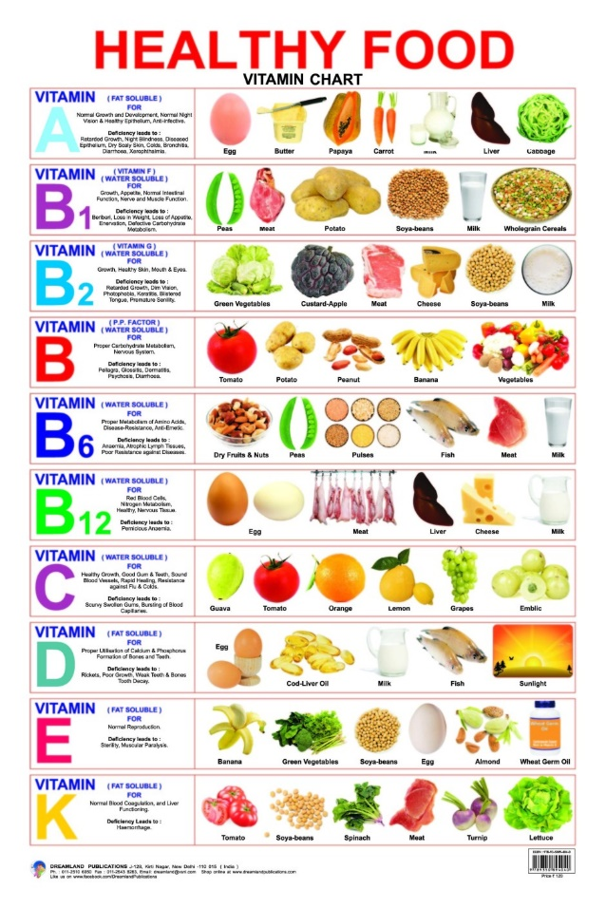  - water-soluble vitamins contain large numbers of electronegative oxygen and nitrogen atoms, which can engage in hydrogen bonding with water. Most water-soluble vitamins act as coenzymes or are required for the synthesis of coenzymes. The fat-soluble vitamins are important for a variety of physiological functions.

